Creating a RESTful API using express.js and creating a database and index in MongoDB.

NAME: SIRI CHANDANA KORUMILLI
EMAIL:chandanakorumilli@gmail.com
PHONE NO: 8919332744
ROLL NO: 20T91A0546 (CSE)
COLLEGE NAME: GIET Engineering College
RESTful API:
Source code:
route.js:
import { NextResponse } from "next/server";

export async function POST(request){
const data = await request.json()
console.log(data)
return NextResponse.json({
data : "hey developer"
})
}
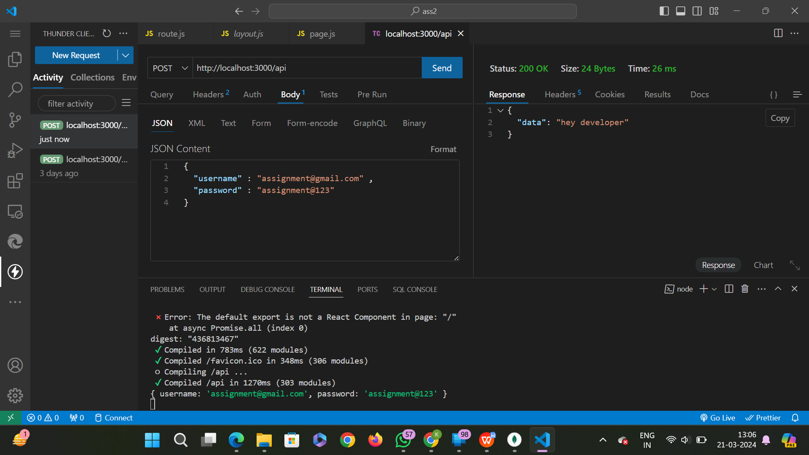
Output:
Creating Database using mongodb:

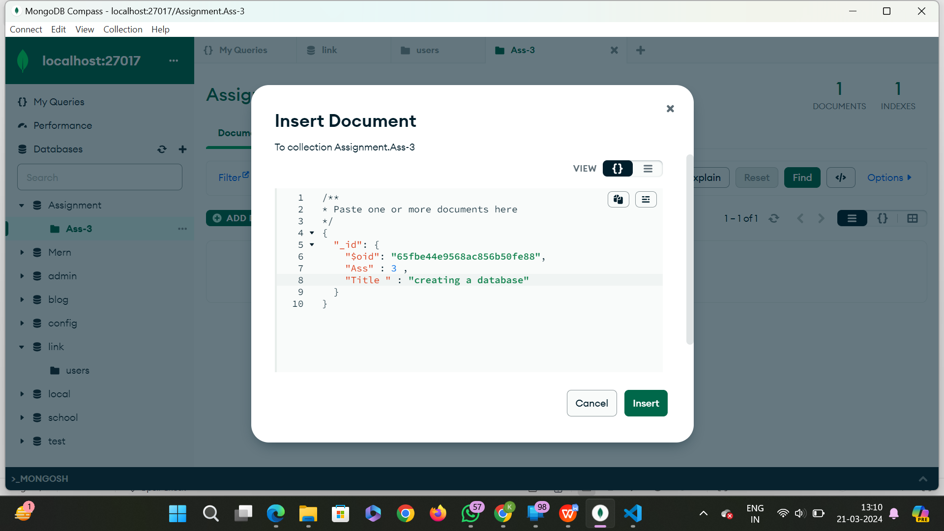

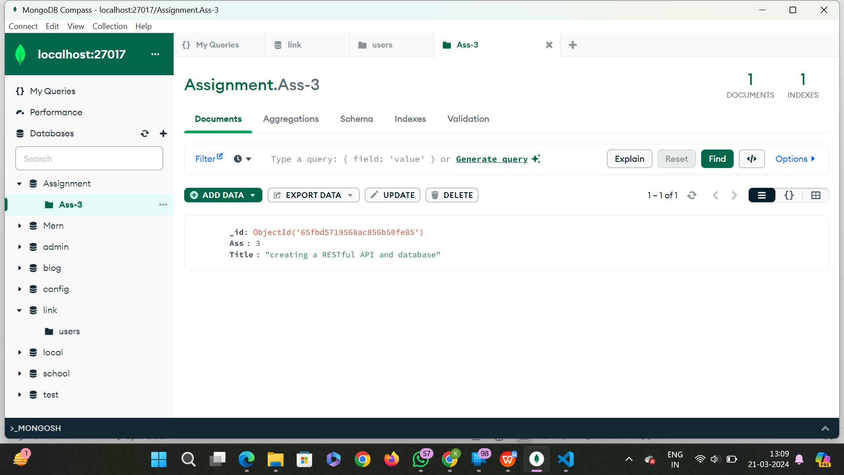
Creating index in mongodb:

